**Exercise: Improving data model performance**

**Introduction**

In this exercise, you must apply your optimization knowledge to identify performance issues and implement optimization in an Adventure Work Microsoft Power BI report. You will be asked to:

* Use **Data view** to examine the data in the report.
* Utilize **Model view** to identify a relationship that requires modification.
* Modify the relationship and adjust the **Cardinality** and **Cross-filter direction** settings.

**Scenario**

Adventure Works is experiencing problems with a key Power BI report. The interface lags, and the visuals are very slow to load. Your manager asks you to help with these issues.

You quickly discover that the reported issues are caused by an unoptimized, bulky data model that accesses and loads the data at a slow pace. To improve the report's performance and efficiency, you must optimize its current data model.

**Instructions**

Download the Adventure Works Power BI report titled *AdventureWorksSales.pbix* and follow the steps below to complete the exercise.

[AdventureWorksSales](https://d3c33hcgiwev3.cloudfront.net/PkavLu9pTCqx41S_UkbrbQ_82952b016974466ea4ba10d8020011e1_AdventureWorksSales.pbix?Expires=1711238400&Signature=IIesaK8rZPGPUYeqp11s6A4gNhvG6tmVIfgNu~UDwJmea1LrbIZvTRQRftpDYyvRpRfoyM~teJoogNDay23j4aDlc3c5RfB-u97f~POMfVkm1Y4YEK1dcXLMbFfFOGNc95CMCBBX2jI-2FYwP-zpbq-YDcLq5ZyoZakaAd32ejA_&Key-Pair-Id=APKAJLTNE6QMUY6HBC5A" \t "_blank)

[PBIX File](https://d3c33hcgiwev3.cloudfront.net/PkavLu9pTCqx41S_UkbrbQ_82952b016974466ea4ba10d8020011e1_AdventureWorksSales.pbix?Expires=1711238400&Signature=IIesaK8rZPGPUYeqp11s6A4gNhvG6tmVIfgNu~UDwJmea1LrbIZvTRQRftpDYyvRpRfoyM~teJoogNDay23j4aDlc3c5RfB-u97f~POMfVkm1Y4YEK1dcXLMbFfFOGNc95CMCBBX2jI-2FYwP-zpbq-YDcLq5ZyoZakaAd32ejA_&Key-Pair-Id=APKAJLTNE6QMUY6HBC5A" \t "_blank)

**Step 1: Open Your Project**

1. Open Power BI Desktop. Select the **File** menu and navigate to where the *AdventureWorksSales.pbix* file is saved. Select the file and click **Open** in the file explorer window to open the saved project in the Power BI Desktop application.

**Step 2: Go to Data View**

1. Use the icons on the vertical toolbar on the left side of the Power BI interface to switch to **Data** view.
2. **Tip:** The **Data** view icon resembles a table. **Data** view allows you to see the data contained in your project. Select the **Orders** view on the right of the screen and take a moment to observe the first 10 records. Note which record has the highest **Order Total** value.

**Step 3: Navigate to Model View**

1. Use the icons on the vertical toolbar on the left side of the Power BI interface to switch to **Model** view. **Tip**: The **Model** view icon shows tables linked by connectors.
2. You should now see a diagram representing all the tables in there port, their fields, and how they are related.

**Step 4: Select Relationships**

1. The lines connecting the tables represent relationships. There is a relationship between the **Customers** and **Orders** tables. Observe the line connecting the **Customers** and **Orders** tables representing the many-to-many relationship you need to modify.

**Tip**: The **many-to-many** relationship is depicted by asterisks on both sides of the line.

1. Double-click the line representing the relationship to access the **Edit Relationship** dialog.
2. In the **Cardinality** drop-down, change the selection from its current state to **one-to-many.**

Tip: **One-to-many** relationships are simpler and faster for Power BI to navigate when loading data and calculating results.

1. In the **Cross filter direction** drop-down, choose the **Single** option to reduce the complexity of the model and limit the direction in which filters are applied.

**Step 5: Review and save your Changes**

* In **Model View,** check the relationship connecting **Customers** to **Orders**. This should now display the number one **(1)** attached to the **Customers** table and an Asterix (**\***) attached to the **Orders** table. This visual confirmation ensures the relationships have been set to **One-to-many** as intended
* Save your Power BI project to your local computer.

**Tip:** Make sure you select an appropriate project name and folder path.

**Conclusion**

When you optimize a data model, you are improving a report's performance and making the information more accessible. This facilitates efficient decision-making and contributes to the success of the organization.

**Exemplar: Improving data model performance**

**Overview**

In the exercise *Improving Data Model Performance*, you were asked to fix a slow-loading Power BI report at Adventure Works. To complete this task, you had to identify bottlenecks in the unoptimized data model and implement changes to improve its efficiency and the overall performance of the report.

More specifically, you were asked to:

* Download the Adventure Works Power BI report titled *AdventureWorksSales.pbix* and open it in Power BI Desktop.
* Switch to **Data** view to observe the records contained in the report and understand the scope of data that the model is dealing with.
* Switch to **Model** view and change the relationship between the **Customers** and **Orders** tables from **Many-to-many** to **One-to-many** to simplify the relationship and improve performance.
* Save the changes and check to ensure that they have been implemented correctly and that the updated data model aligns with the adjustments.

This reading provides you with a guide that you can use as a benchmark for your solution. You can also refer to the videos *Resolving performance issues in the data model.*

**Step 1: Open Your Project**

1. In **Power BI Desktop**, select **File** in the top left corner. On the **File** menu, select **Open Report**.

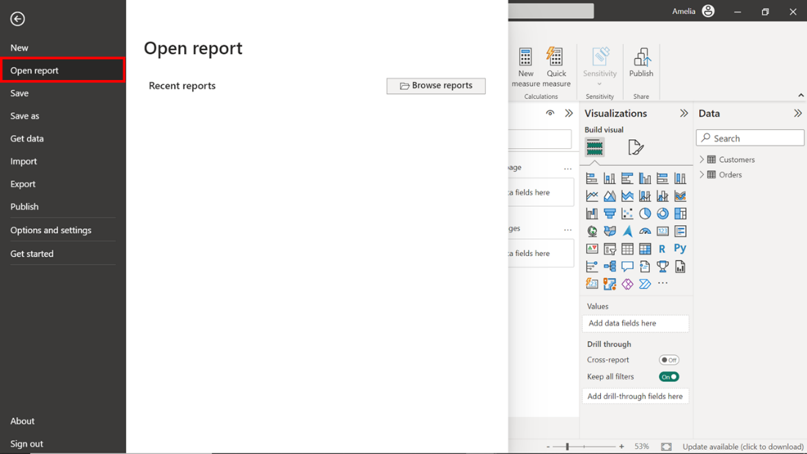

1. A dropdown menu will then appear where you select **Browse Reports**. Selecting this causes the file explorer window to open. Navigate to the location where you’re the downloaded file *AdventureWorksSalesReport.pbix* is saved.
2. Select the file and click **Open** in the **File explorer** window. This action opens the saved project in the **Power BI Desktop** application.

**Step 2: Go to Data View**

1. In the **Power BI Desktop** window, you'll find a vertical toolbar with different icons on the left-hand side. The second icon from the top resembles a table and is the **Data** view icon. Select this icon to switch to **Data v**iew.

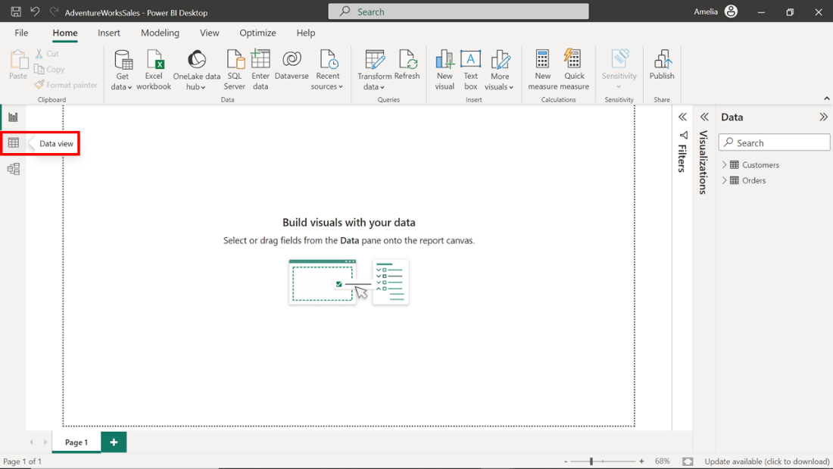

1. Power BI switches to **Data view** and displays the data contained in the project. Viewing this data can help you to understand the granularity and structure of the data at the most basic level. This information about the data and its structures is crucial for any kind of data analysis or data modeling. Select the **Orders** table on the right of the screen and take a moment to observe the first ten records. The order identified by **Order ID 2003** carries the highest **Order Total** value of **$5400** amongst the first ten records. This could result from various factors such as the quantity of goods ordered, the individual cost of each item, and the application of any taxes, fees, or discounts. It also suggests efficient transaction processing and could indicate a high-value customer.

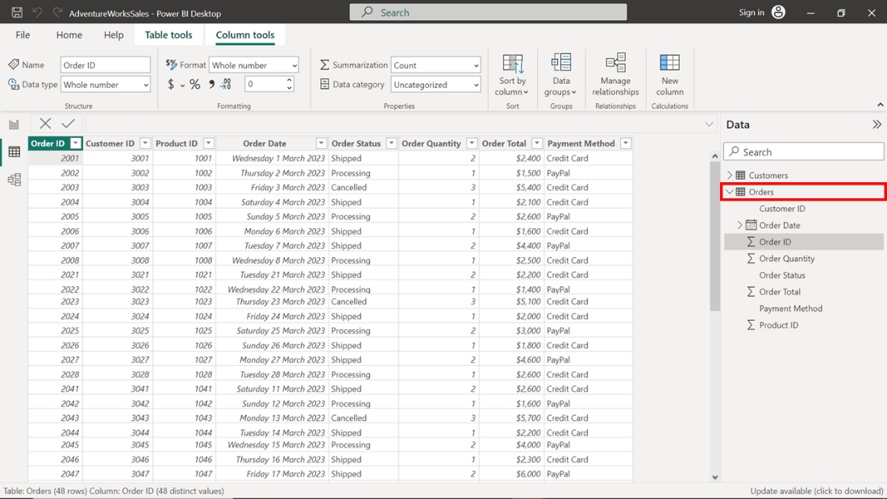

**Step 3: Navigate to Model View**

1. The next step asks that you switch to **Model view.** To do this, select a different icon in the vertical toolbar on the left side of the Power BI interface.  Choosing the third icon from the top switches to **Model view**. This icon shows three tables linked with connectors. Select this icon.

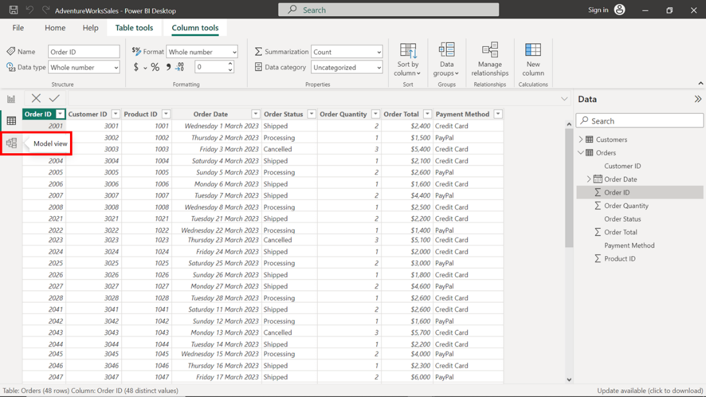

1. **Model view** displays a graphical representation of the tables in your report and the relationships between them. You can use this high-level overview to quickly identify and understand how different tables are interconnected. This is crucial when making modifications to improve performance.

**Step 4: Select Relationships**

1. **Model view** displays a network of tables connected by lines that represent the relationships between the tables. The **Customers** and **Orders** tables line shows a many-to-many relationship (depicted by asterisks on both sides of line) that you must modify. Modification is important because it lets you configure relationships that are simpler and faster for Power BI to navigate when loading data and calculating results.

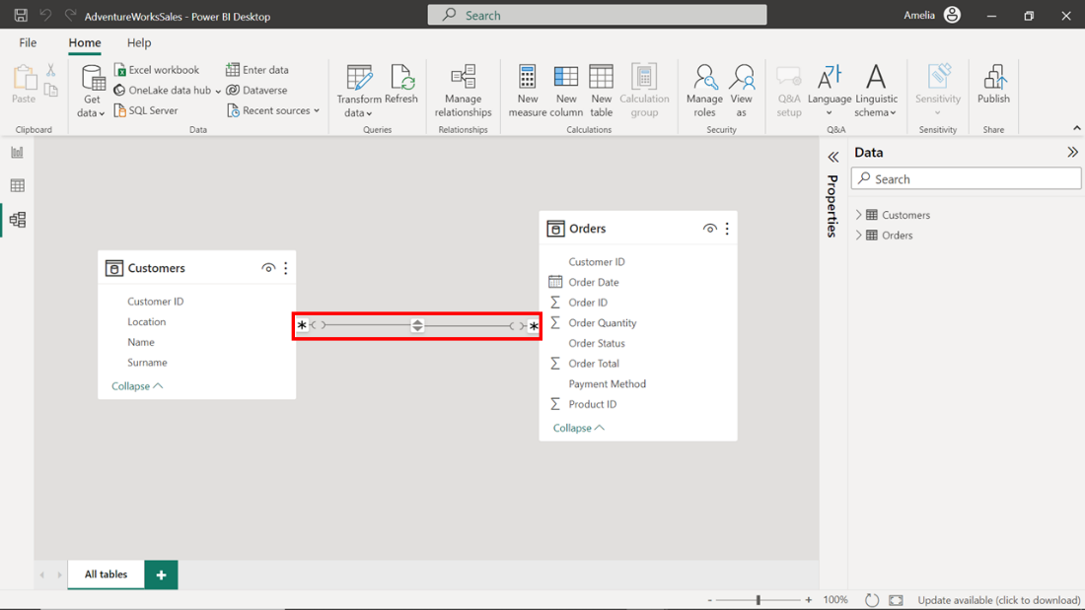

1. To modify the relationship, double-click on the line to open the **Edit relationship** dialog. The dialog box displays the properties of the two linked tables, **Customers** and **Orders**, and provides options to edit various aspects of the relationship, including **Cross filter direction** and **Cardinality**. To optimize the data model, you'll need to adjust both properties.
2. In the **Cardinality** drop-down, change the selection from its current state of **Many-to-many** to **One-to-many**. Adjusting the **Cardinality** from **Many-to-many** to **One-to-many** can improve performance because **One-to-many** relationships are simpler and faster for Power BI to navigate when loading data and calculating results.

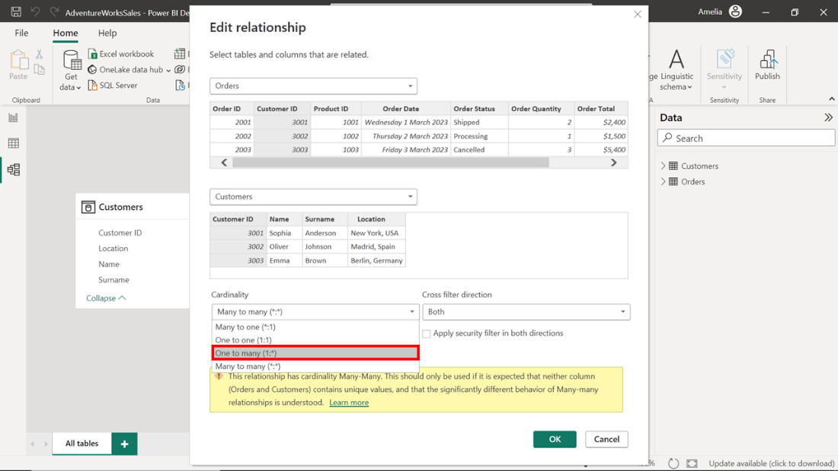

1. In the **Cross-filter direction** drop-down, choose the **Single** option to reduce the complexity of the model and limit the direction in which filters are applied. The logic behind these changes is simple: one customer can have many orders, but each order can belong to only one customer. Adjusting these settings to reflect the actual business relationships will improve the efficiency and accuracy of your data model.

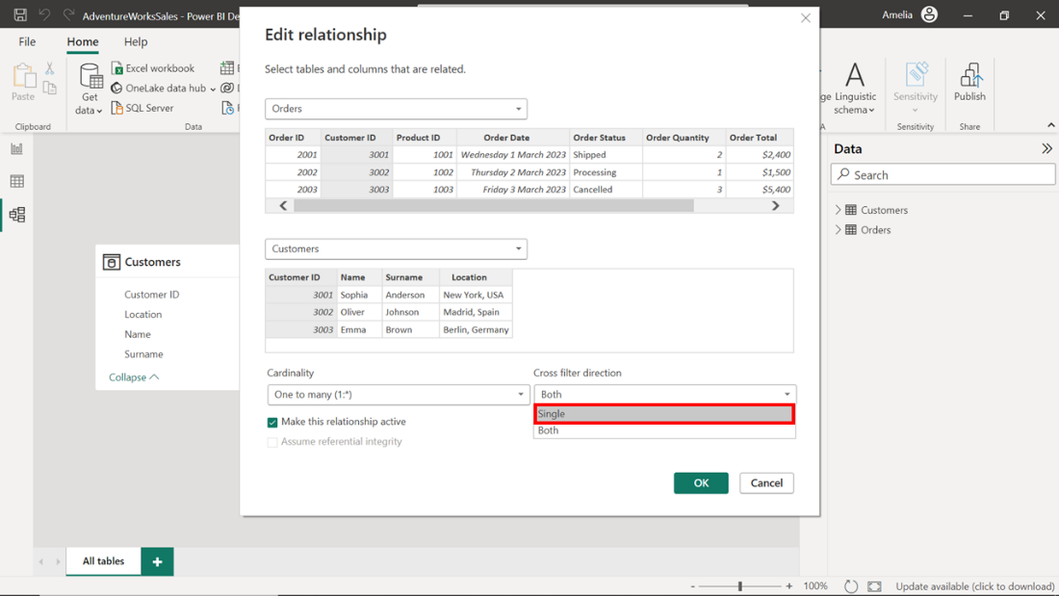

**Step 5: Save the Changes**

1. Once you have modified the relationship properties for **Customers** and **Orders** you must save these changes for them to take effect. To save the changes made to the data model, select the **OK** button located at the bottom right corner of the dialog box.

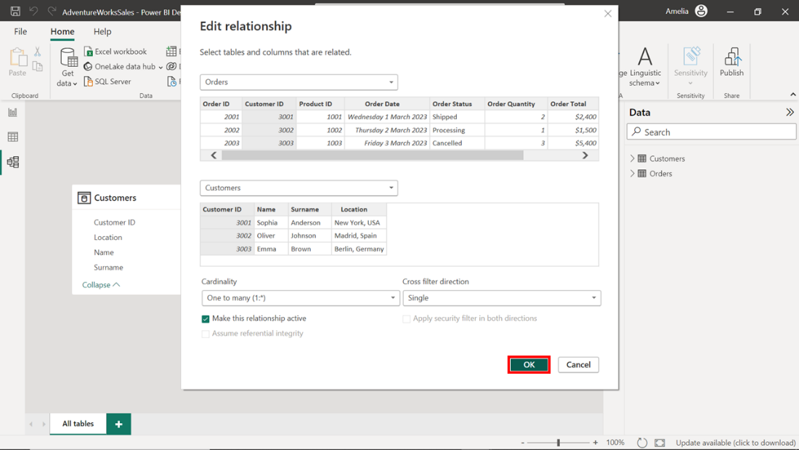

1. Once the changes are saved, review and confirm that they have been implemented by checking the relationships in the **Model view.** The line connecting **Customers** to **Orders** should now display the number one (**1**) attached to the **Customers** table and an asterisk (**\***) attached to the **Orders** table. This confirms that the relationship has been set to **One-to-many** as intended.

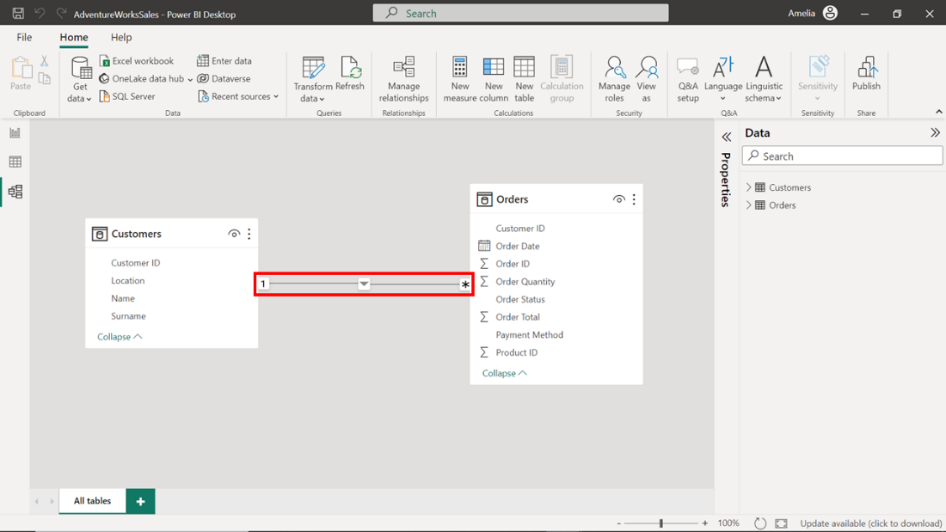

**Conclusion**

The changes you have made to the data model in this project file will improve the quality and efficiency of the report. Streamlining the relationships in the model allows Power BI to process the data efficiently and generate visuals more quickly. This improved performance will benefit your colleagues in the Sales department who first flagged the poorly performing report. Well done!

Remember, slow-loading reports can be an opportunity, not a problem. It's an invitation to investigate, optimize, and uncover ways to make data work better.